Use a Git branch to merge a file
Being a space station administrator comes with certain responsibilities. Sometimes you’ll need to keep information locked down, especially when mapping out new locations in the solar system. Learning branches will allow you to update your files and only share the information when you're ready.
Branches are most powerful when you're working on a team. You can work on your own part of a project from your own branch, pull updates from Bitbucket, and then merge all your work into the main branch when it's ready. Our documentation includes more explanation of why you would want to use branches.
A branch represents an independent line of development for your repository. Think of it as a brand-new working directory, staging area, and project history. Before you create any new branches, you automatically start out with the main branch (called master ). For a visual example, this diagram shows the master branch and the other branch with a bug fix update.

Step 1. Create a branch and make a change
Create a branch where you can add future plans for the space station that you aren't ready to commit. When you are ready to make those plans known to all, you can merge the changes into your Bitbucket repository and then delete the no-longer-needed branch.
It's important to understand that branches are just pointers to commits. When you create a branch, all Git needs to do is create a new pointer—it doesn’t create a whole new set of files or folders. Before you begin, your repository looks like this:
To create a branch, do the following:
- Go to your terminal window and navigate to the top level of your local repository using the following command:
$ cd ~/repos/bitbucketstationlocations/
- Create a branch from your terminal window.
$ git branch future-plans
This command creates a branch but does not switch you to that branch, so your repository looks something like this:
The repository history remains unchanged. All you get is a new pointer to the current branch. To begin working on the new branch, you have to check out the branch you want to use.
- Checkout the new branch you just created to start using it.
- $ git checkout future-plans
Switched to branch 'future-plans'
The git checkout command works hand-in-hand with gitbranch . Because you are creating a branch to work on something new, every time you create a new branch (with git branch), you want to make sure to check it out (with git checkout) if you're going to use it. Now that you’ve checked out the new branch, your Git workflow looks something like this:
- Search for the bitbucketstationlocations folder on your local system and open it. You will notice there are no extra files or folders in the directory as a result of the new branch.
- Open the stationlocations file using a text editor.
- Make a change to the file by adding another station location:
- <p>Bitbucket has the following space stations:</p>
- <p>
- <b>Earth's Moon</b><br>
- Headquarters
- </p>
- <p>
- <b>Mars</b><br>
- Recreation Department
</p>
- Save and close the file.
- Enter git status in the terminal window. You will see something like this:
- $ git status
- On branch future-plans
- Changes not staged for commit:
- (use "git add <file>..." to update what will be committed)
- (use "git checkout -- <file>..." to discard changes in working directory)
- modified: stationlocations
no changes added to commit (use "git add" and/or "git commit -a")
Notice the On branch future-plans line? If you entered git status previously, the line was on branch master because you only had the one master branch. Before you stage or commit a change, always check this line to make sure the branch where you want to add the change is checked out.
- Stage your file.
$ git add stationlocations
- Enter the git commit command in the terminal window, as shown with the following:
- $ git commit stationlocations -m 'making a change in a branch'
- [future-plans e3b7732] making a change in a branch
1 file changed, 4 insertions(+)
With this recent commit, your repository looks something like this:
Now it's time to merge the change that you just made back into the master branch.

Step 2. Merge your branch: fast-forward merging
Your space station is growing, and it's time for the opening ceremony of your Mars location. Now that your future plans are becoming a reality, you can merge your future-plans branch into the main branch on your local system.
Because you created only one branch and made one change, use the fast-forward branch method to merge. You can do a fast-forward merge because you have a linear path from the current branch tip to the target branch. Instead of “actually” merging the branches, all Git has to do to integrate the histories is move (i.e., “fast-forward”) the current branch tip up to the target branch tip. This effectively combines the histories, since all of the commits reachable from the target branch are now available through the current one.
This branch workflow is common for short-lived topic branches with smaller changes and are not as common for longer-running features.
To complete a fast-forward merge do the following:
- Go to your terminal window and navigate to the top level of your local repository.
$ cd ~/repos/bitbucketstationlocations/
- Enter the git status command to be sure you have all your changes committed and find out what branch you have checked out.
- $ git status
- On branch future-plans
nothing to commit, working directory clean
- Switch to the master branch.
- $ git checkout master
- Switched to branch 'master'
Your branch is up-to-date with 'origin/master'.
- Merge changes from the future-plans branch into the masterbranch. It will look something like this:
- $ git merge future-plans
- Updating fcbeeb0..e3b7732
- Fast-forward
- stationlocations | 4 ++++
1 file changed, 4 insertions(+)
You've essentially moved the pointer for the master branch forward to the current head and your repository looks something like the fast forward merge above.
- Because you don't plan on using future-plans anymore, you can delete the branch.
- $ git branch -d future-plans
Deleted branch future-plans (was e3b7732).
When you delete future-plans, you can still access the branch from master using a commit id. For example, if you want to undo the changes added from future-plans, use the commit id you just received to go back to that branch.
- Enter git status to see the results of your merge, which show that your local repository is one ahead of your remote repository. It will look something like this:
- $ git status
- On branch master
- Your branch is ahead of 'origin/master' by 1 commit.
- (use "git push" to publish your local commits)
nothing to commit, working directory clean
Here's what you've done so far:
- Created a branch and checked it out
- Made a change in the new branch
- Committed the change to the new branch
- Integrated that change back into the main branch
- Deleted the branch you are no longer using.
Next, we need to push all this work back up to Bitbucket, your remote repository.

Step 3. Push your change to Bitbucket
You want to make it possible for everyone else to see the location of the new space station. To do so, you can push the current state of your local repository to Bitbucket.
This diagram shows what happens when your local repository has changes that the central repository does not have and you push those changes to Bitbucket.
Here's how to push your change to the remote repository:
- From the repository directory in your terminal window, enter git push origin master to push the changes. It will result in something like this:
- $ git push origin master
- Counting objects: 3, done.
- Delta compression using up to 8 threads.
- Compressing objects: 100% (3/3), done.
- Writing objects: 100% (3/3), 401 bytes | 0 bytes/s, done.
- Total 3 (delta 0), reused 0 (delta 0)
- To https://emmap1@bitbucket.org/emmap1/bitbucketstationlocations.git
fcbeeb0..e3b7732 master -> master
- Click the Overview page of your Bitbucket repository, and notice you can see your push in the Recent Activity stream.
- Click Commits and you can see the commit you made on your local system. Notice that the change keeps the same commit id as it had on your local system.
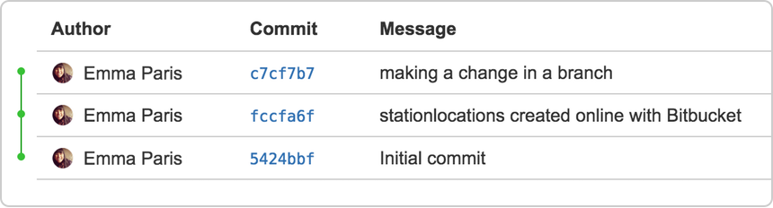
You can also see that the line to the left of the commits list has a straight-forward path and shows no branches. That’s because the future-plans branch never interacted with the remote repository, only the change we created and committed.
- Click Branches and notice that the page has no record of the branch either.
- Click Source, and then click the stationlocations file. You can see the last change to the file has the commit id you just pushed.
- Click the file history list to see the changes committed for this file, which will look similar to the following figure.
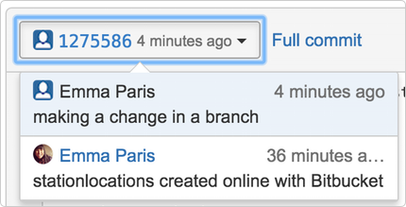

You are done!
Not sure you will be able to remember all the Git commands you just learned? No problem. Bookmark our basic Git commands page so that you can refer to it when needed.

Next up:

Learn about code review in Bitbucket Cloud

